## Video Source: [2 Quick Methods for the IELTS Speaking 1-Minute Preparation Time](https://www.youtube.com/watch?v=wTePj4_qGLE)

## [Understand IELTS Speaking in JUST 9 Minutes!](https://www.youtube.com/watch?v=MowXdaxK0fQ)

## Method 1:

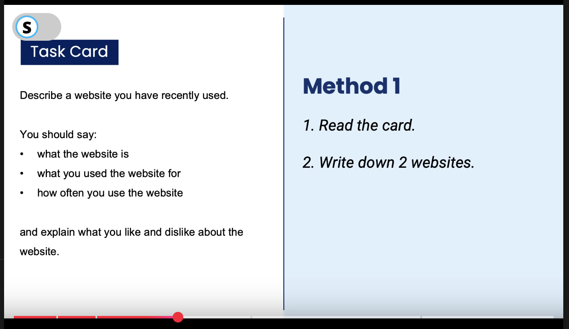

## Method 2: Use the PPF(Past Present Future) method

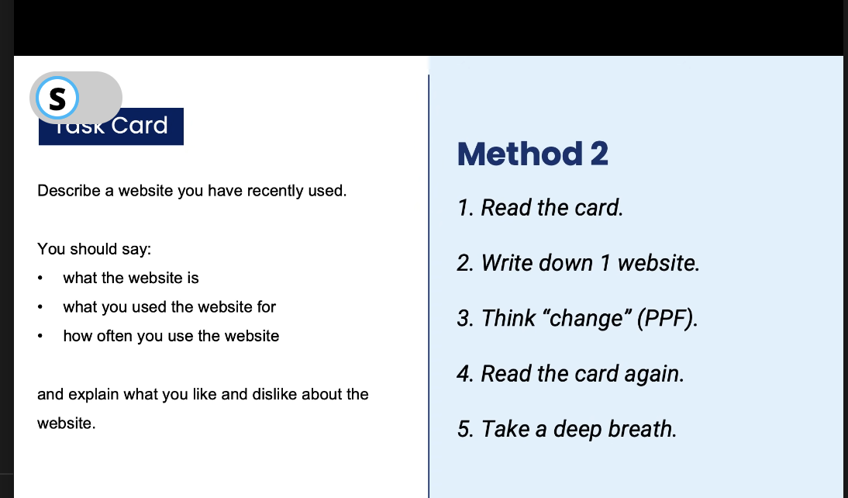

## IELTS Speaking Structure:

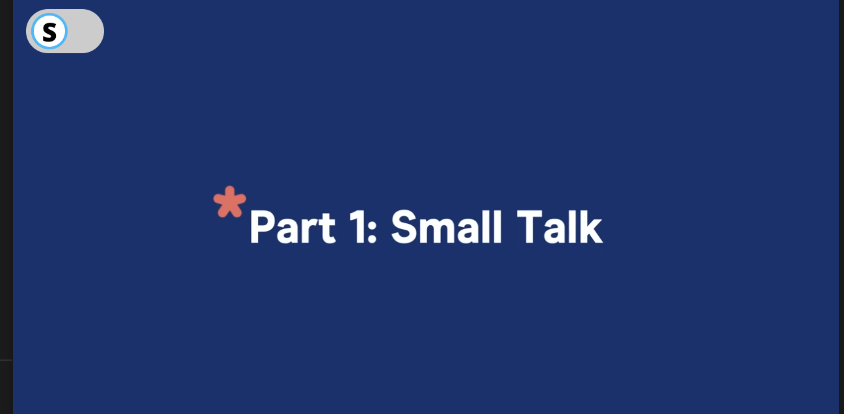

Mandatory Questions:

Do you live in an apartment or a house?

Are you a student or do you work?

Then questions would be generic:

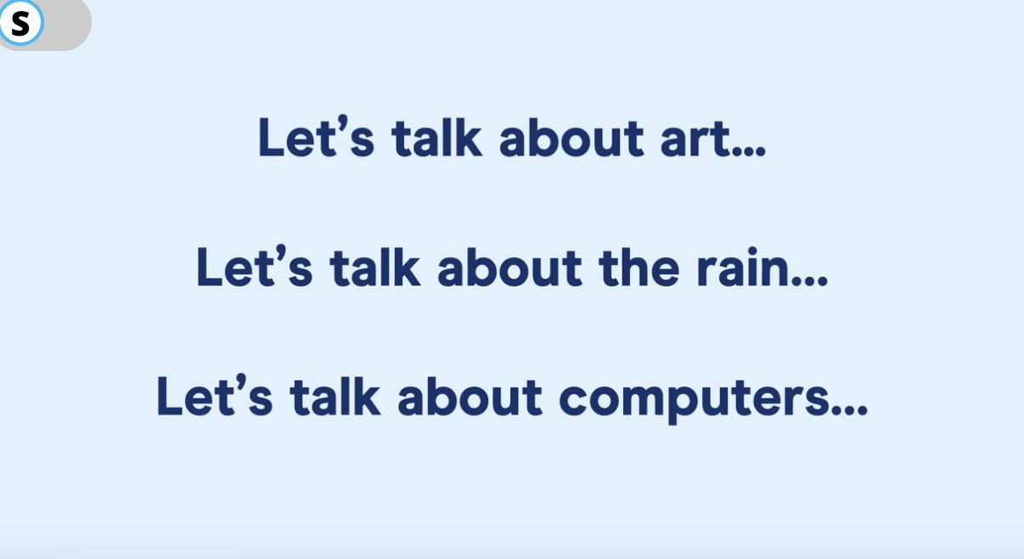

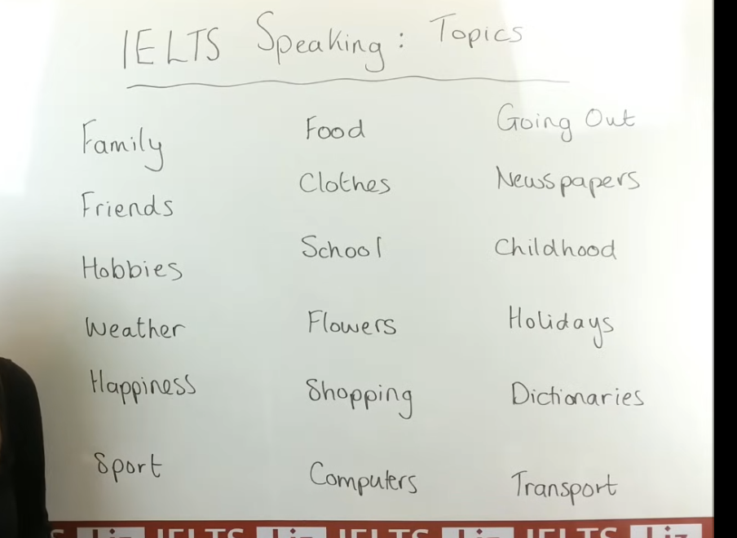

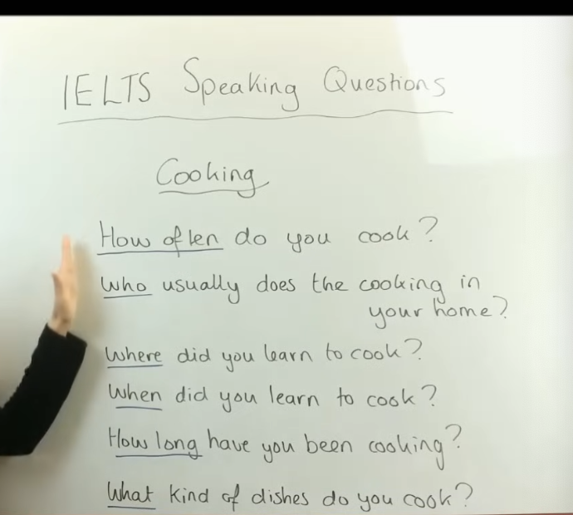

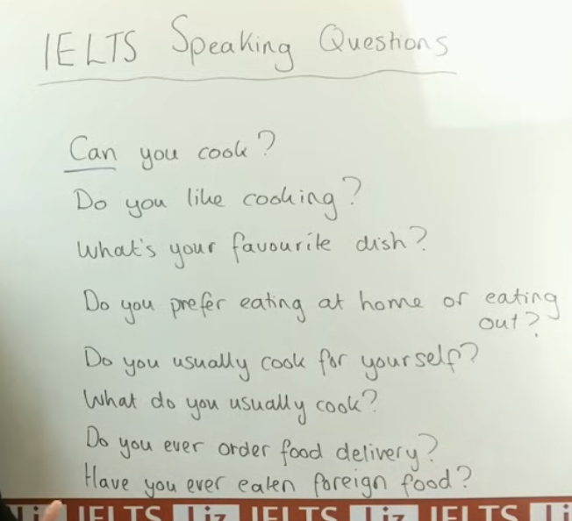

Listen for the starting keywords such as Can, What, When, Have, etc.

Like for example, “Did” informs you that it's from the past tense.

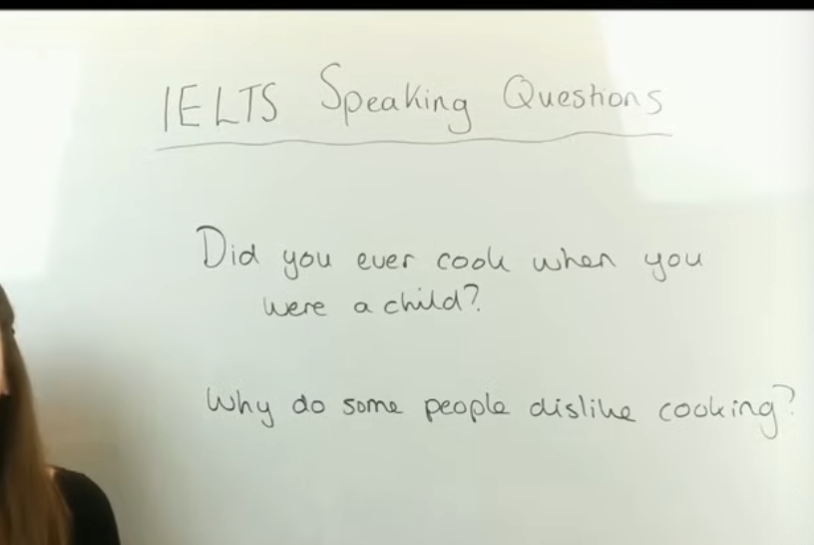

For example, in the 2nd question, you may provide some points or suggestions on why people dislike cooking

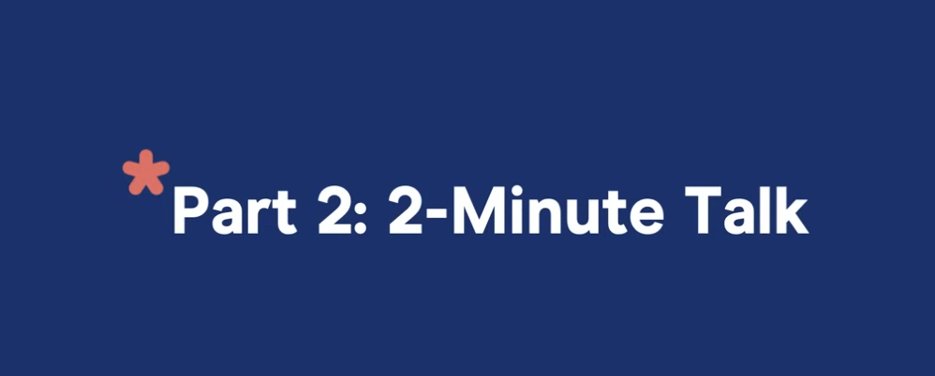

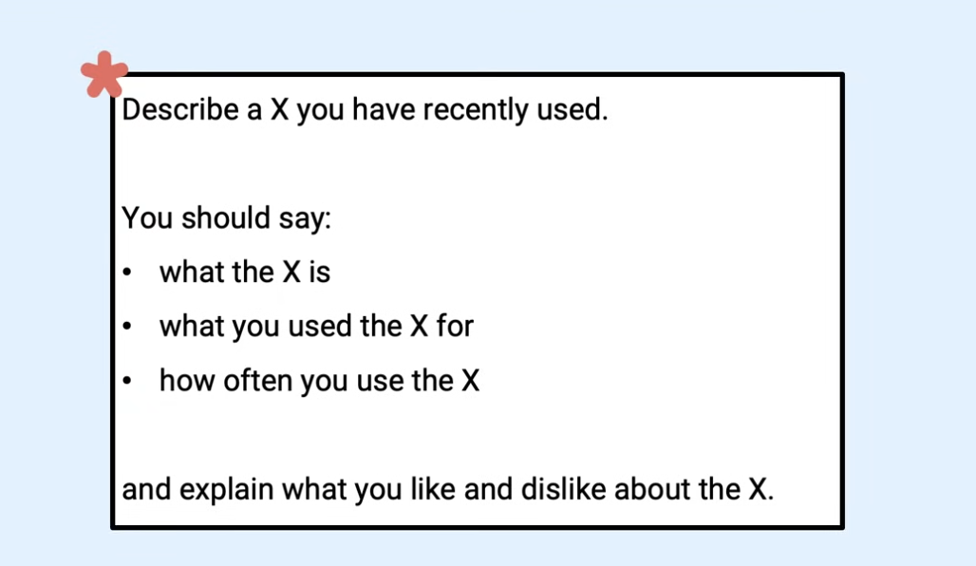



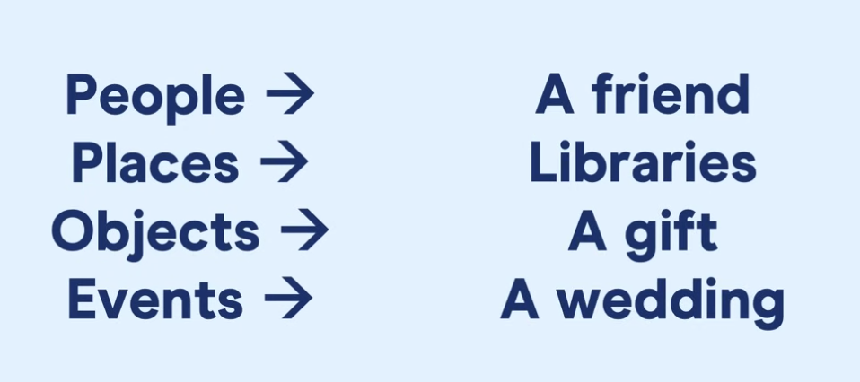



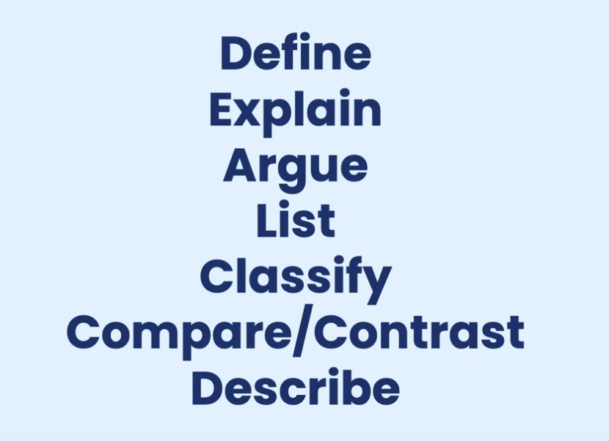

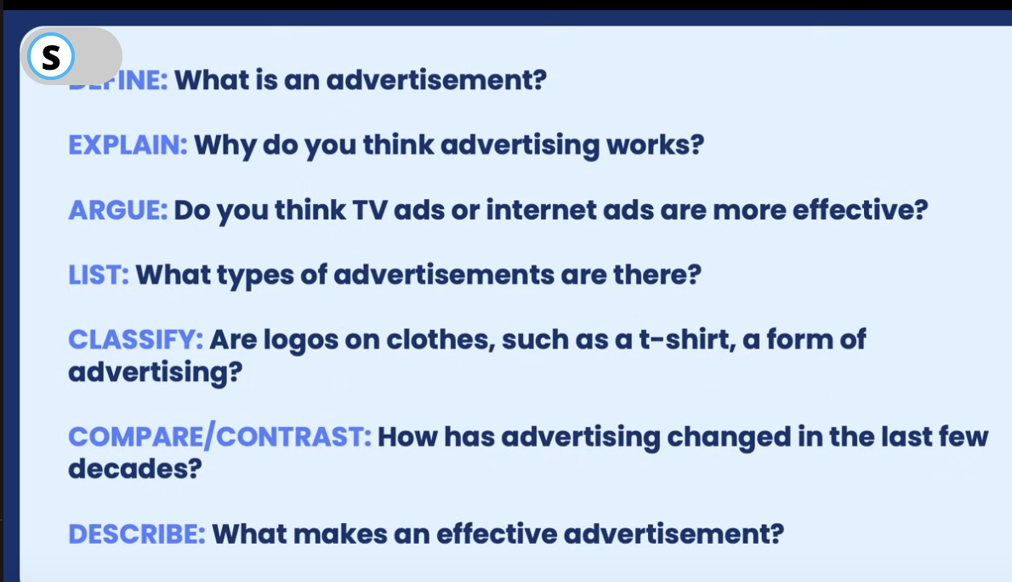



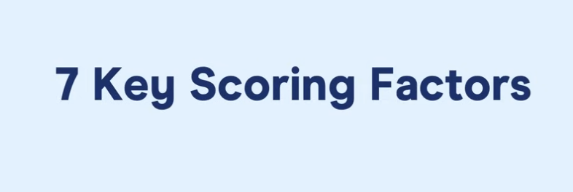

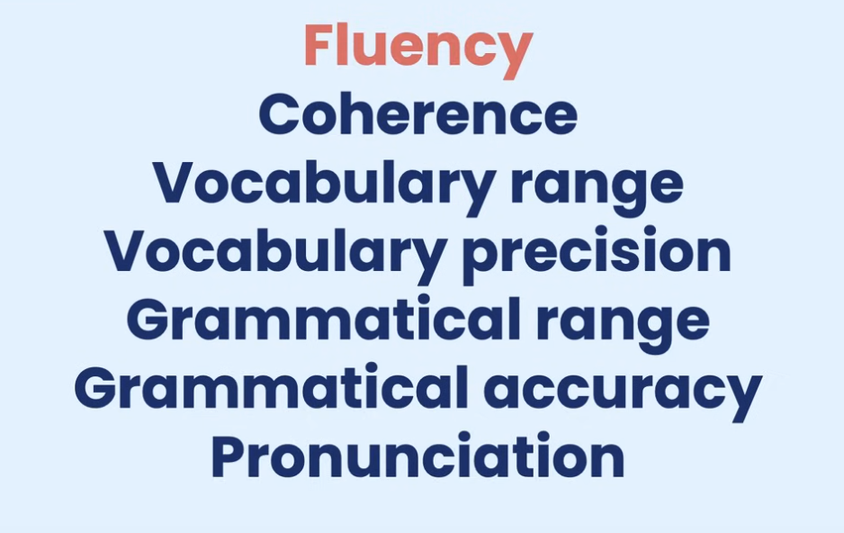

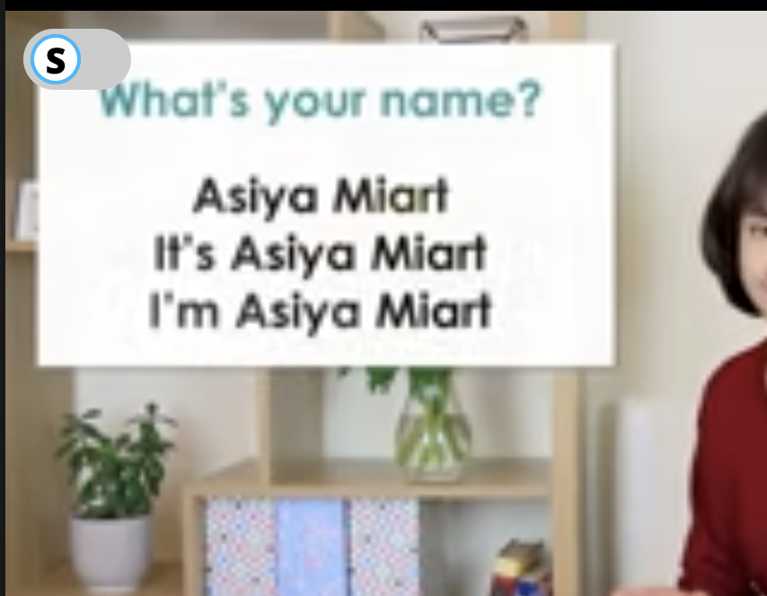

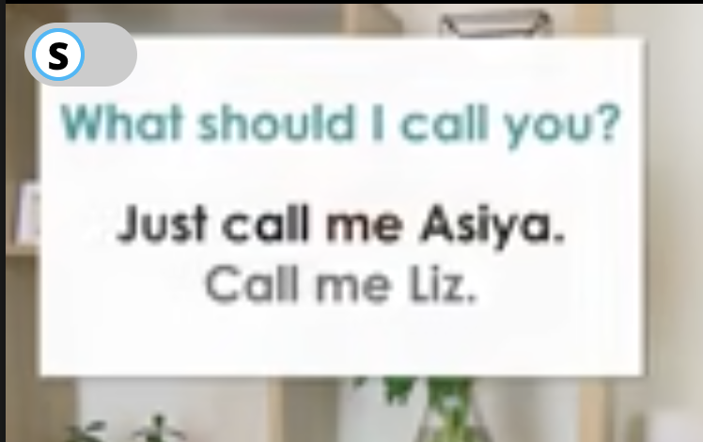

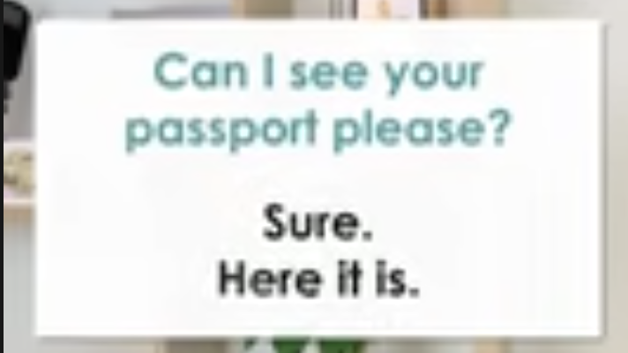

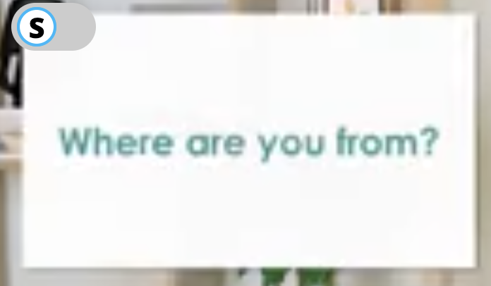

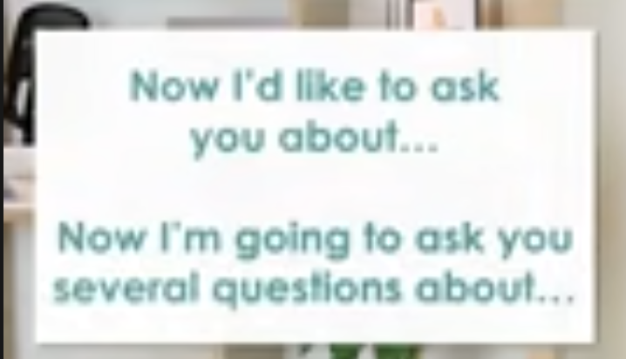

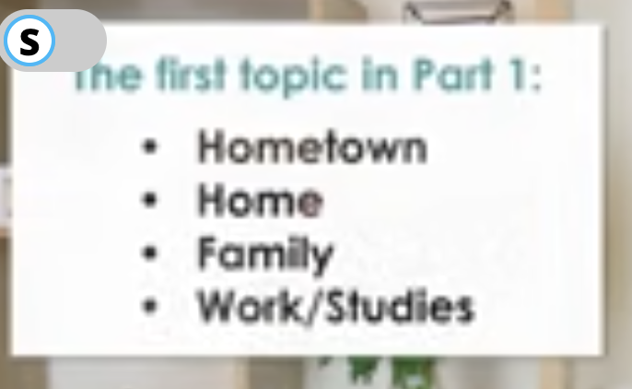

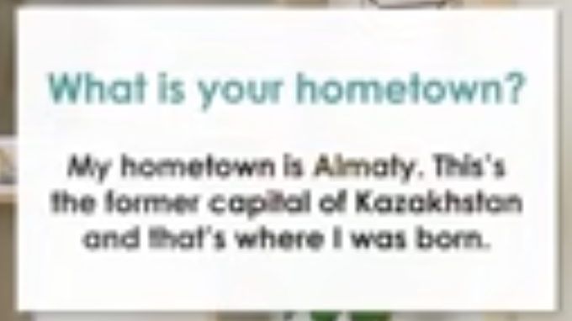

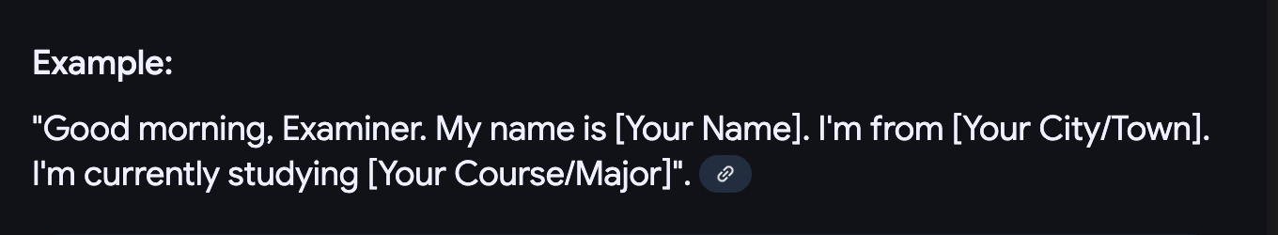

[**How to Introduce Yourself in IELTS Speaking (BAND 9 START)**](https://www.youtube.com/watch?v=jEVAwb-muZo)

[**Nail Your 1st Topic in IELTS Speaking**](https://www.youtube.com/watch?v=CT0dVUtTuwg)

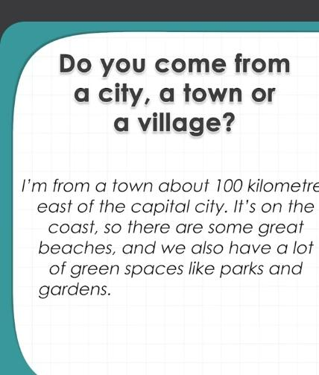

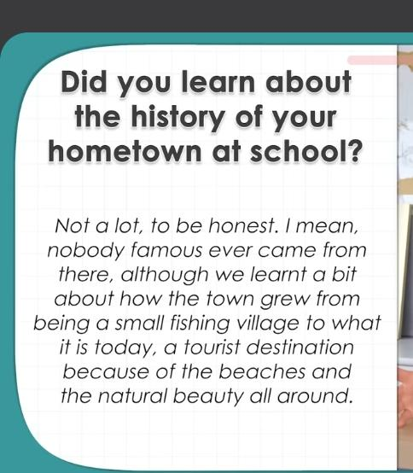

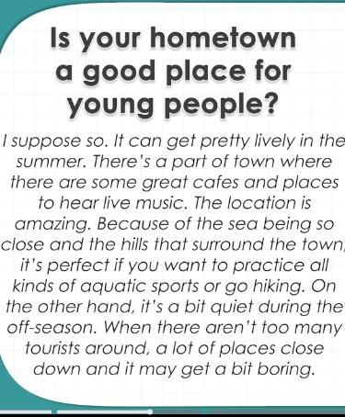

Give small explanation with reasons which may have both pros and cons

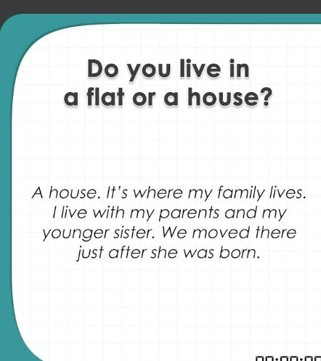

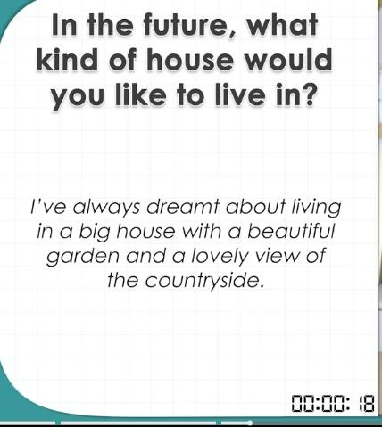

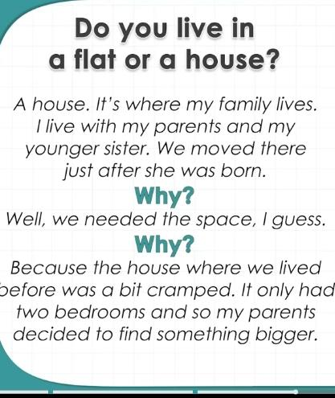

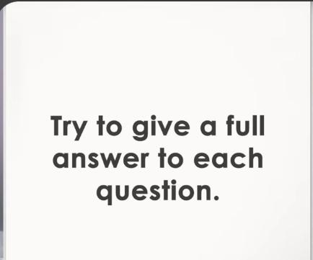



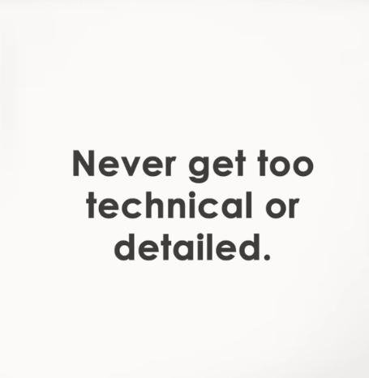

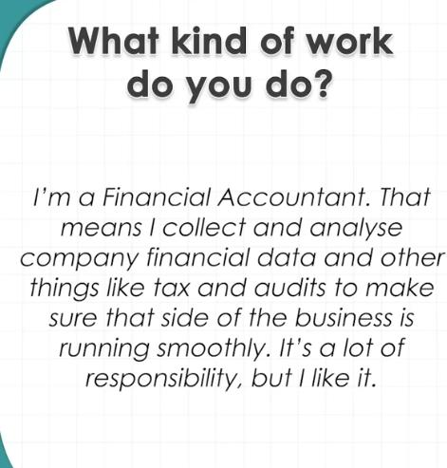

[IELTS Speaking test band score of 9 with feedback](https://youtu.be/u9cggZHjwS4?si=sK4I_Nf5IpYKrrrG)

[Give Me 15 mins, And I'll Boost Your Speaking Score to Band 9](https://youtu.be/5_A5vjLgDec?si=gijhe-38jP350ppa)

**Vocabulary:** Use precise and topic-specific words.

* **Example:** Instead of "good," use "remarkable," "exceptional," or "outstanding" depending on the context.

**Grammar:** Apply grammar rules correctly and consistently.

* **Example:** Use a variety of sentence structures (simple, compound, complex) and verb tenses accurately.

**Fluency:** Speak smoothly with minimal hesitations.

* **Example:** If you need time to think, use filler words like "well" or "actually" instead of long pauses.

**Pronunciation:** Focus on clear articulation.

* **Example:** Practice saying words aloud, paying attention to stress and intonation.

**Impatience:** Understand that language learning is a gradual process.

* **Example:** Set realistic goals and celebrate small improvements.

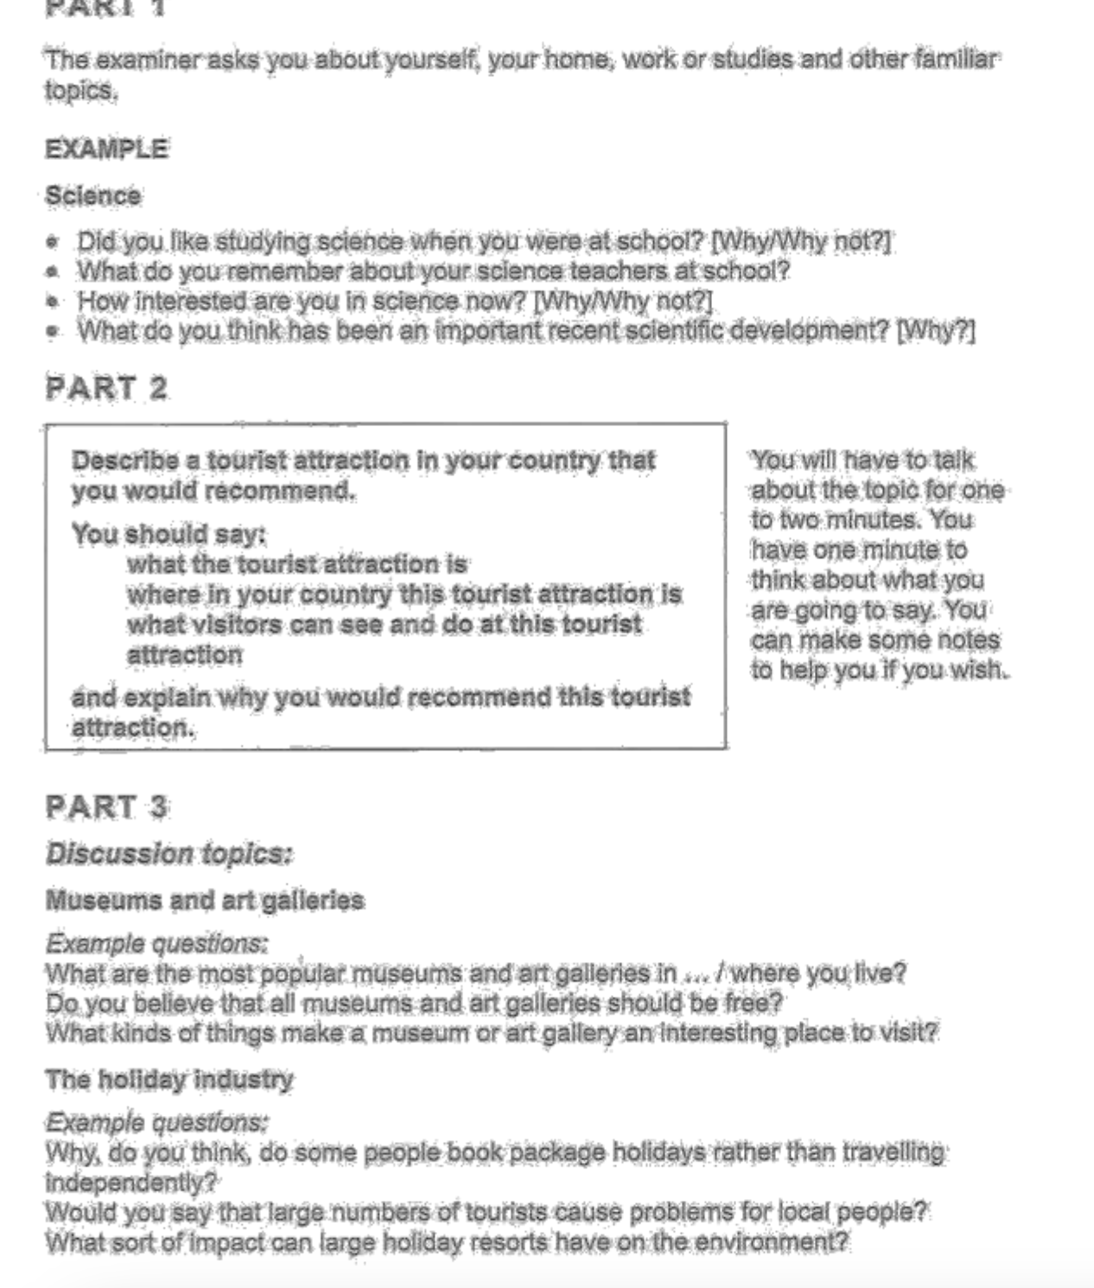

Part 2:

<https://youtu.be/H7ZEWMYKnrI>

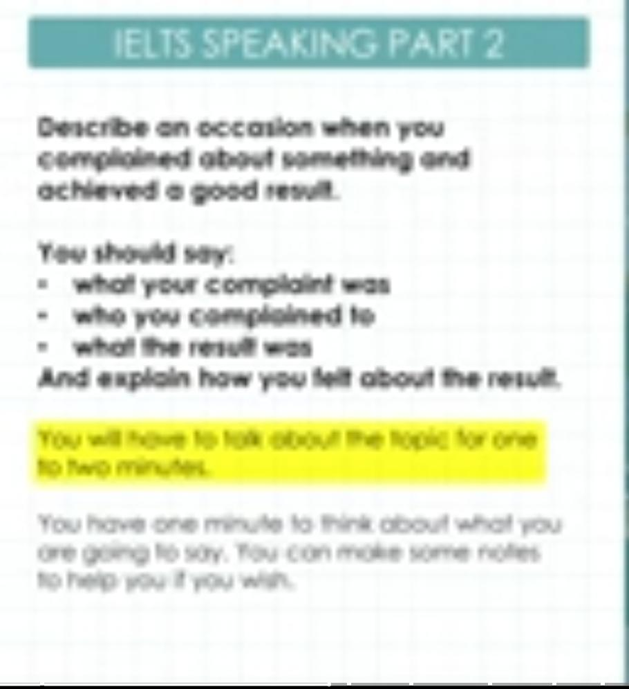

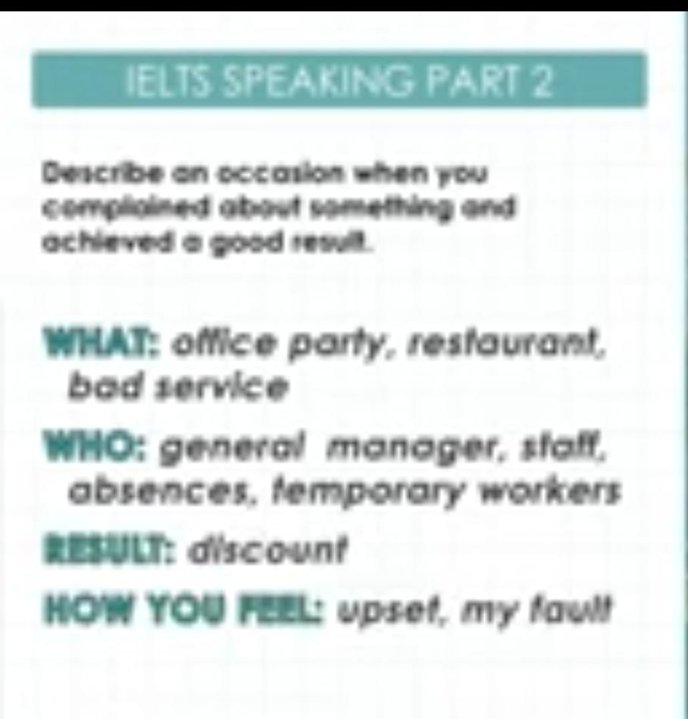

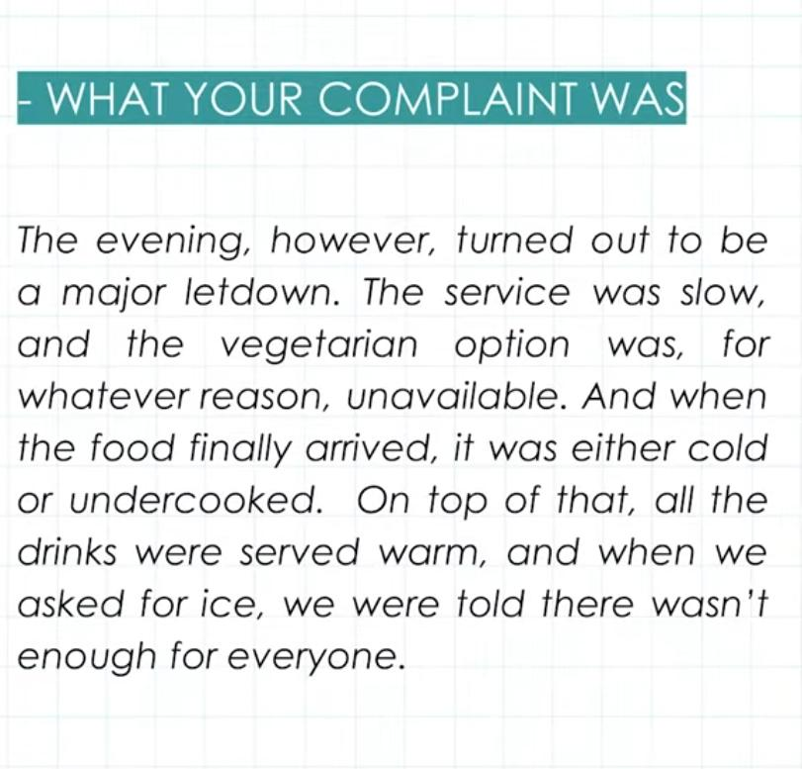

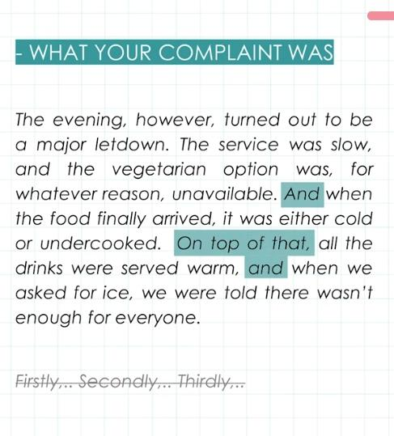

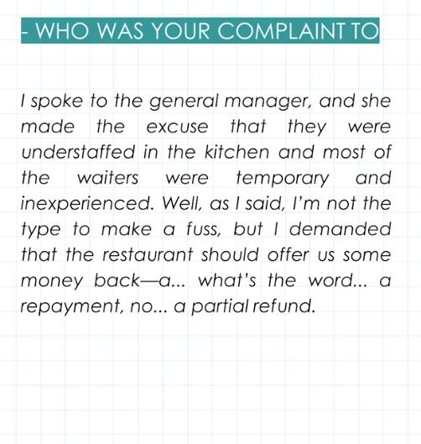

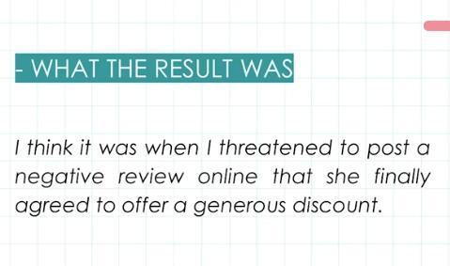

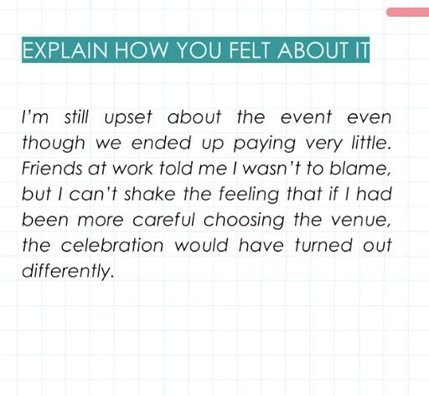

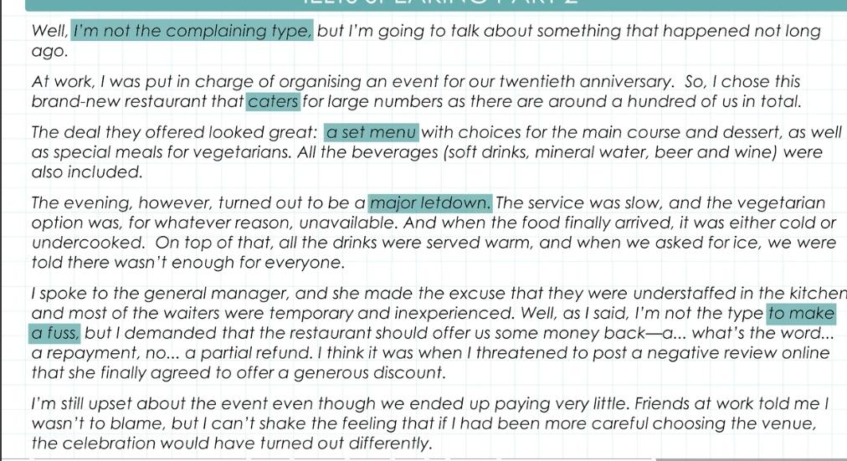

Part 3:

<https://youtu.be/-yN3zoJ5LYw>